

**BEWEGING EN TRILLINGEN**

*Jonas Neeckx*

*Nicolas Heintz*

**Linkages: The Colibri**

PAPER

Titularis

Joris De Schutter

ACADEMIEJAAR 2017-2018

Index

1. Introduction 3

2. Motion analysis and dead configurations 5

2.1 Motion analysis 5

2.2 Dead configurations 5

3. Kinematic analysis 6

3.1 Loop equations 6

3.2 Position analysis 7

3.3 Velocity analysis 8

3.4 Acceleration analysis 9

3.5 Control 12

3.5.1 Position 12

3.5.2 Velocity 14

3.5.3 Acceleration 15

4. Dynamic analysis 17

4.1 Centre of gravity 17

4.2 Masses and moments of inertia 18

4.3 Acceleration and velocities 19

4.4 Force equations 20

4.5 Results 24

4.5.1 Internal forces 24

4.5.2 Torque on the motor 26

4.5.3 Force and torque after static balancing 26

4.5.4 Shaking forces 27

4.6 Control 28

4.7 Strength analysis 30

# Introduction

In this paper we will discuss a kinematic and inverse dynamical analysis of a Colibri bird. The Colibri is represented by a nine-bar linkage system with eleven joints and a slider. A drawing of the system can be found in figure 1. The names on the figure are used through the entire paper. Joints A, D, G, H and K are connected to the ground. Bar two is the driver of the system and rotates around joint A with a constant speed. Point C is a slider and will always stay directly under joint A. The length of bars four and eight are variable to make the desired motion of the system possible. The angles between bars eight and nine and bars four and five are not variable (8-9 is one bar and 4-5 is one bar). The angles five and nine are determined by angles four and eight and a non-variable angle gamma. The initial values of the parameters can be found in figure 2.

This paper will start with the motion analysis and a discussion about any possible dead configurations. After this a kinematic analysis of the system is done to determine the positions, velocities and accelerations of the bars and joints. After checking these results, a dynamic analysis is used to calculate the internal and external forces of the system.

All results in this paper are based on a realistic movement of the wings of 37Hz.

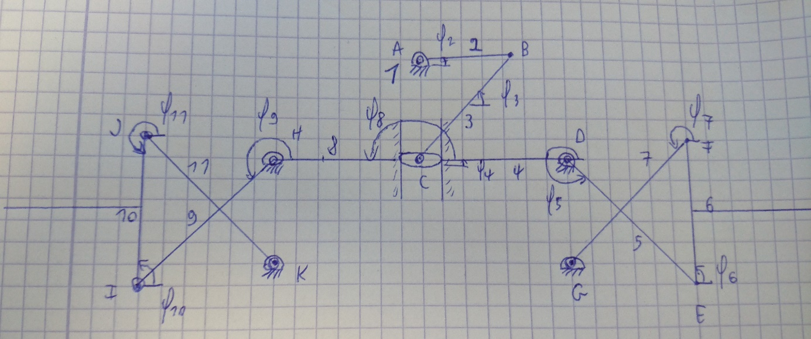

Figure 1: Drawing of the nine-bar system



Figure 2: Lengths, mass and initial angles of the system

# Motion analysis and dead configurations

## Motion analysis

A motion analysis is used to determine the degree of freedom of the system.

$M=3(n-1)-2f_{1}-f_{2}$

n = 9 (the number of links) The angle between bars eight and nine and bars four and five are fixed so they both count as one bar. They are named separately to make the calculations easier to understand.

f1 = 11 joints that remove two degrees of freedom (A,B,C,D,E,F,G,H,I,J,K)

f2 = 1 joint that removes one degree of freedom (C)

Joint C is used twice in the calculation of the mobility, once as a joint with one degree of freedom and once as a slider with two degrees of freedom.

This gives us a mobility of one which means one variable can be chosen to determine the entire system. In this case $φ_{2}$, the angle which drives bar two is chosen.

## Dead configurations

The system has no dead configurations. $φ_{2}$ doesn’t have any limitations.

# Kinematic analysis

## Loop equations

There are ten unknown parameters of the system left. Angles three till eleven, the length of bar 4, the length of bar 8 and the distance between joints A and C.   
The entire system can be determined by ten independent equations or five loops in which each loop has an x and a y equation. The loop equations can be found in figure 3.

Phi5 and phi9 can be written in function of phi4 and phi8 as shown in loops four and five.

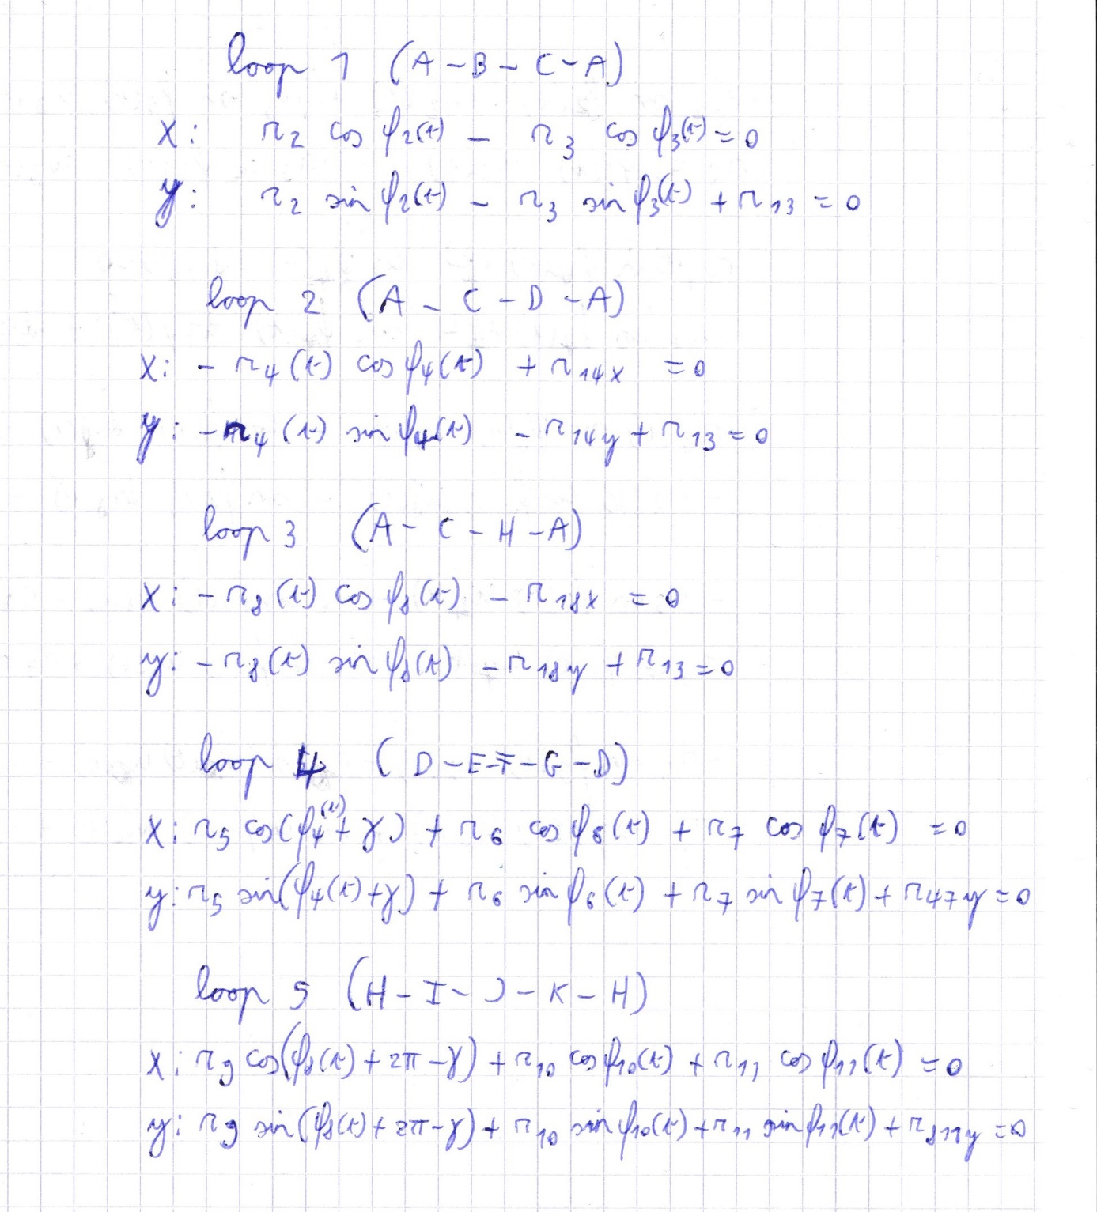

Figure 3: Loop equations

## Position analysis

Matlab solves the system of ten equations and ten variables using fsolve. Fsolve calculates the angles in time based on the initial values given and $φ_{2}$.

The results can be found in figures 4 and 5.

The symmetry of the system can be found in these figures, angles 6 and 10 both start at an angle of 90 degrees and will change in opposite direction. R4 and r8 are always the same length. This is already a good indicator that the position analysis is correct.

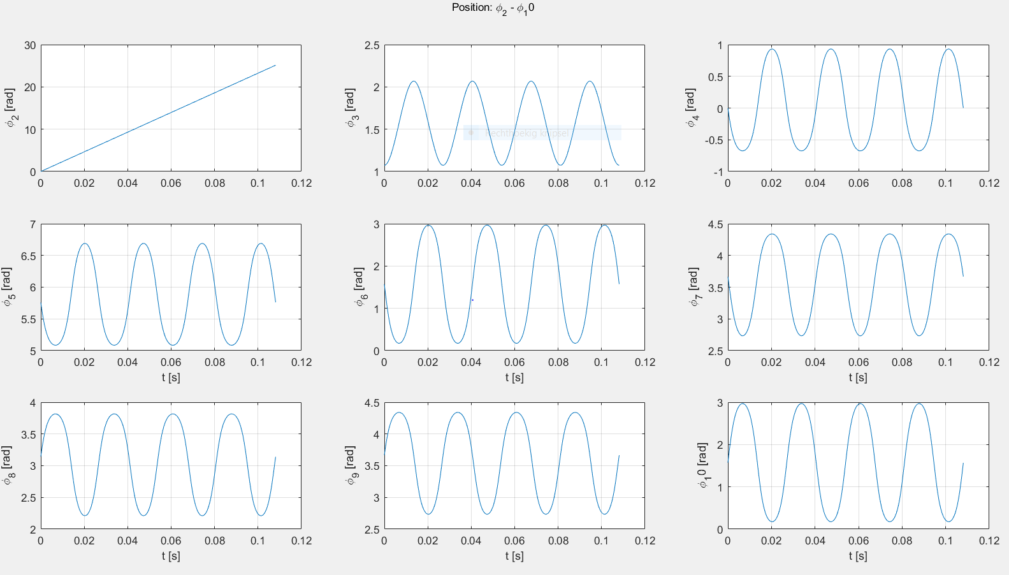

Figure 4: Angles two through 10 plot in function of time

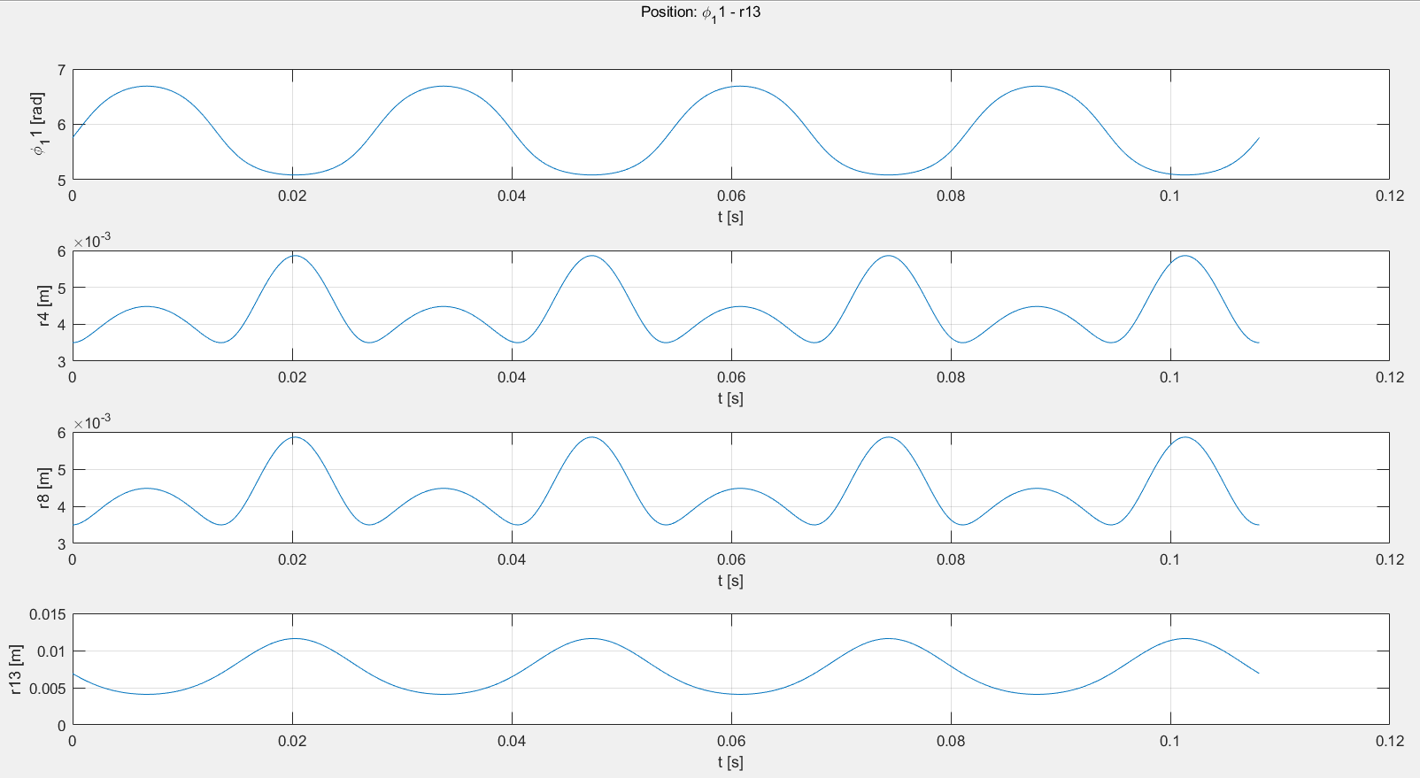

Figure 5: Angle 11 and the three variable lengths plot in function of time

## Velocity analysis

The velocity analysis can be done based on the closure equations by taking the time derivative of these equations. This yields a set of ten equations in ten unknowns. These unknowns can be calculated using matlab. The derived equations can be found in figure 6. The results can be found in figures 7 and 8. In these figures the symmetry can again be found.

As these figures are the derivatives of the previous figures 5 and 6 the graphs of figures 7 and 8 should go through zero when the graphs of figures 5 and 6 go through an extremum. This is the case and shows that the calculations are probably correct.

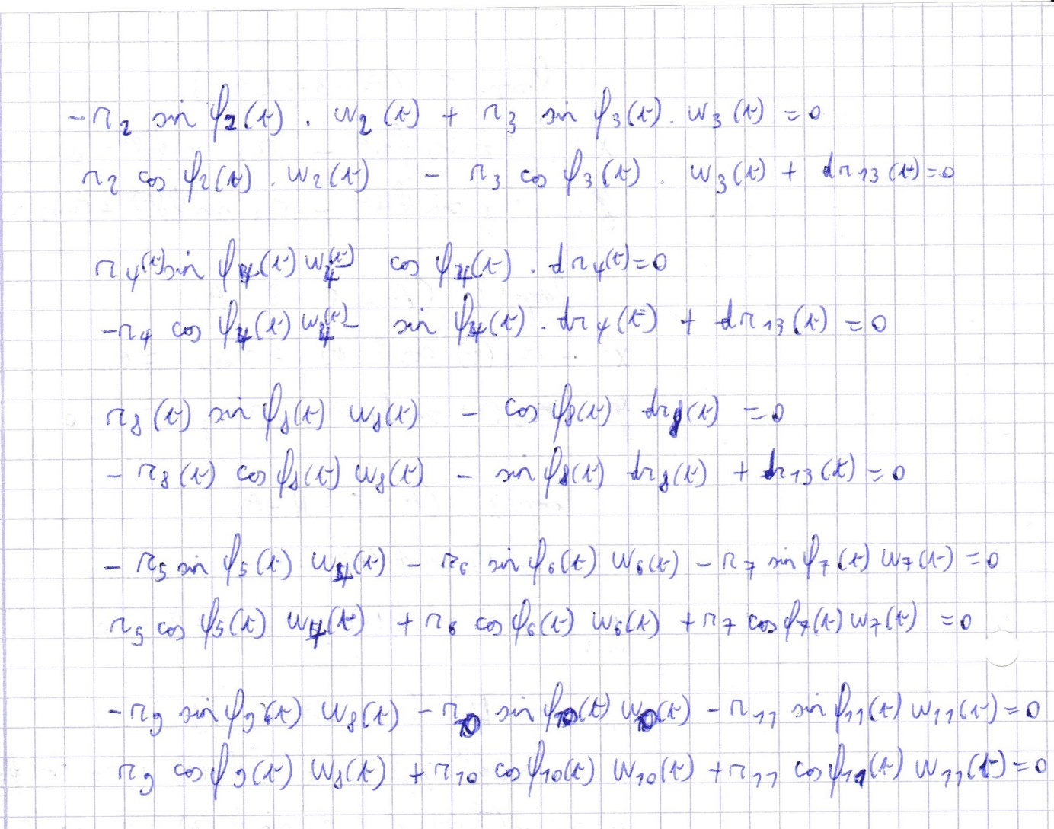

Figure 6: Derivatives of the loop equations

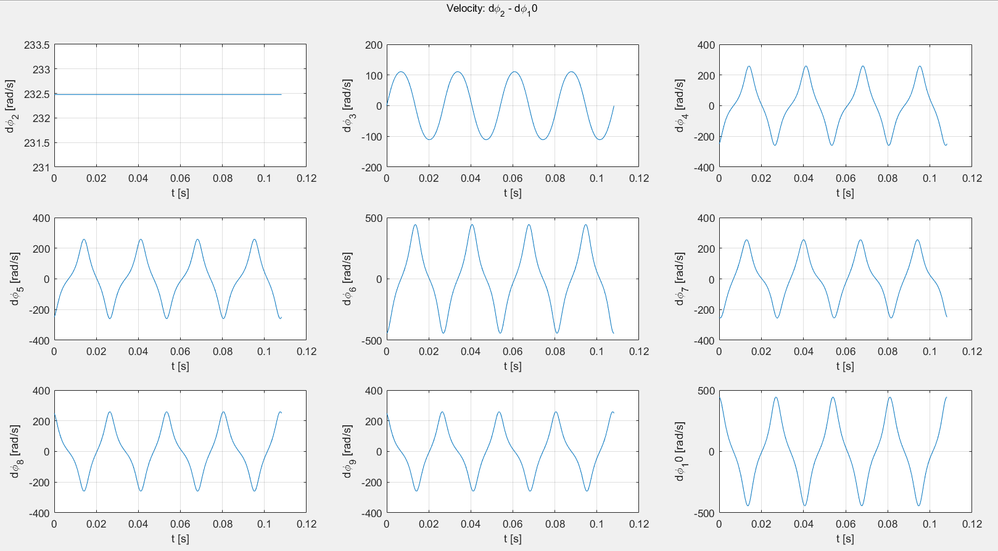

Figure 7: Omega 2 through 10 plot in function of time

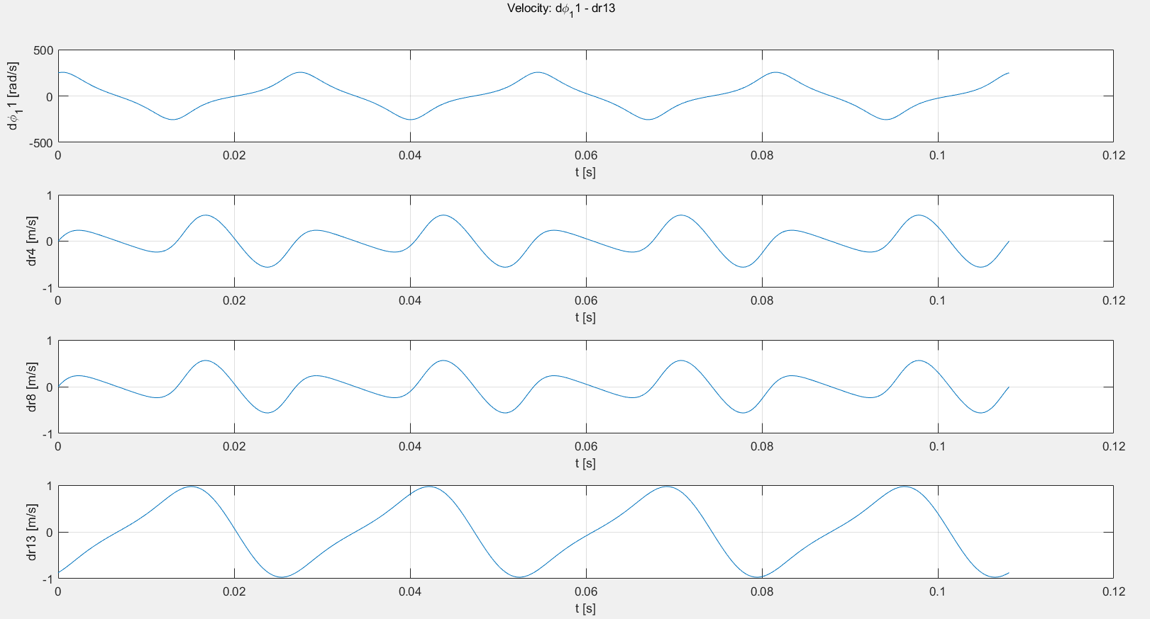

Figure 8: Omega 11 and the velocities of the change in length of bars 4,8 and distance 13 plot in function of time

## Acceleration analysis

The acceleration analysis is done by taking the derivative of the velocity analysis equations. This yields another ten equations in ten unknowns which can be calculated with matlab. The equations can be found in figure 9 and the results can be found in figures 10 and 11. And the same clear symmetry of the system can be seen.

As these figures are the derivatives of the previous figures 7 and 8 the graphs of figures 10 and 11 should go through zero when the graphs of figures 7 and 8 go through an extremum. This is the case and shows that the calculations are probably correct.

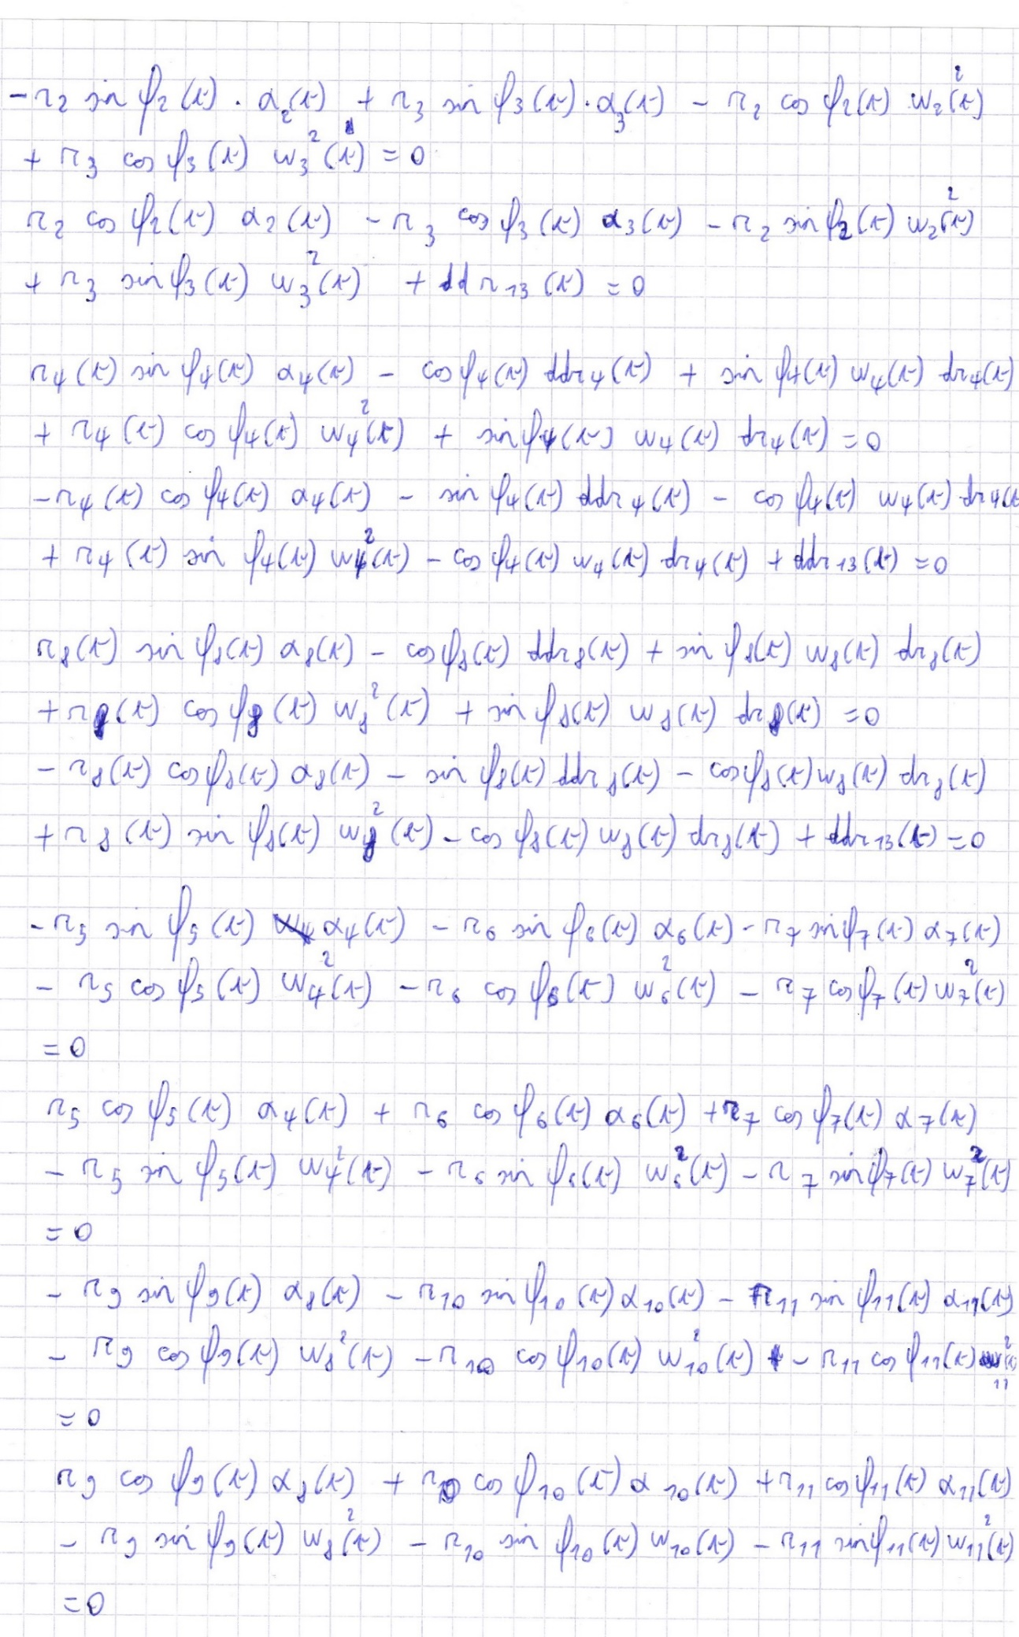

Figure 9: The derivatives of the velocity equations (the acceleration equations)

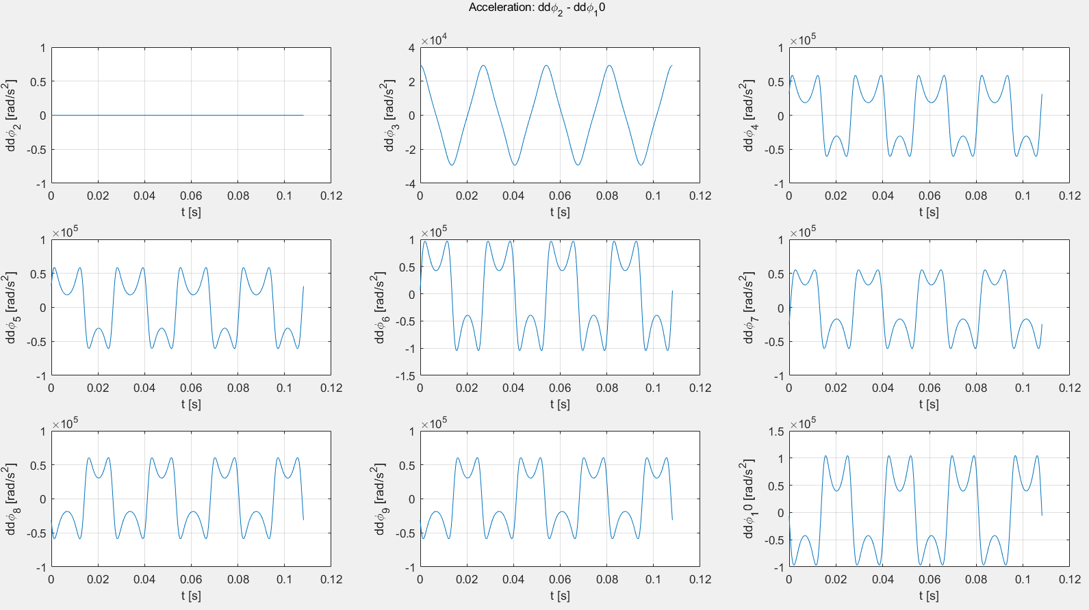

Figure 10: Alpha 2 through 10 in function of time

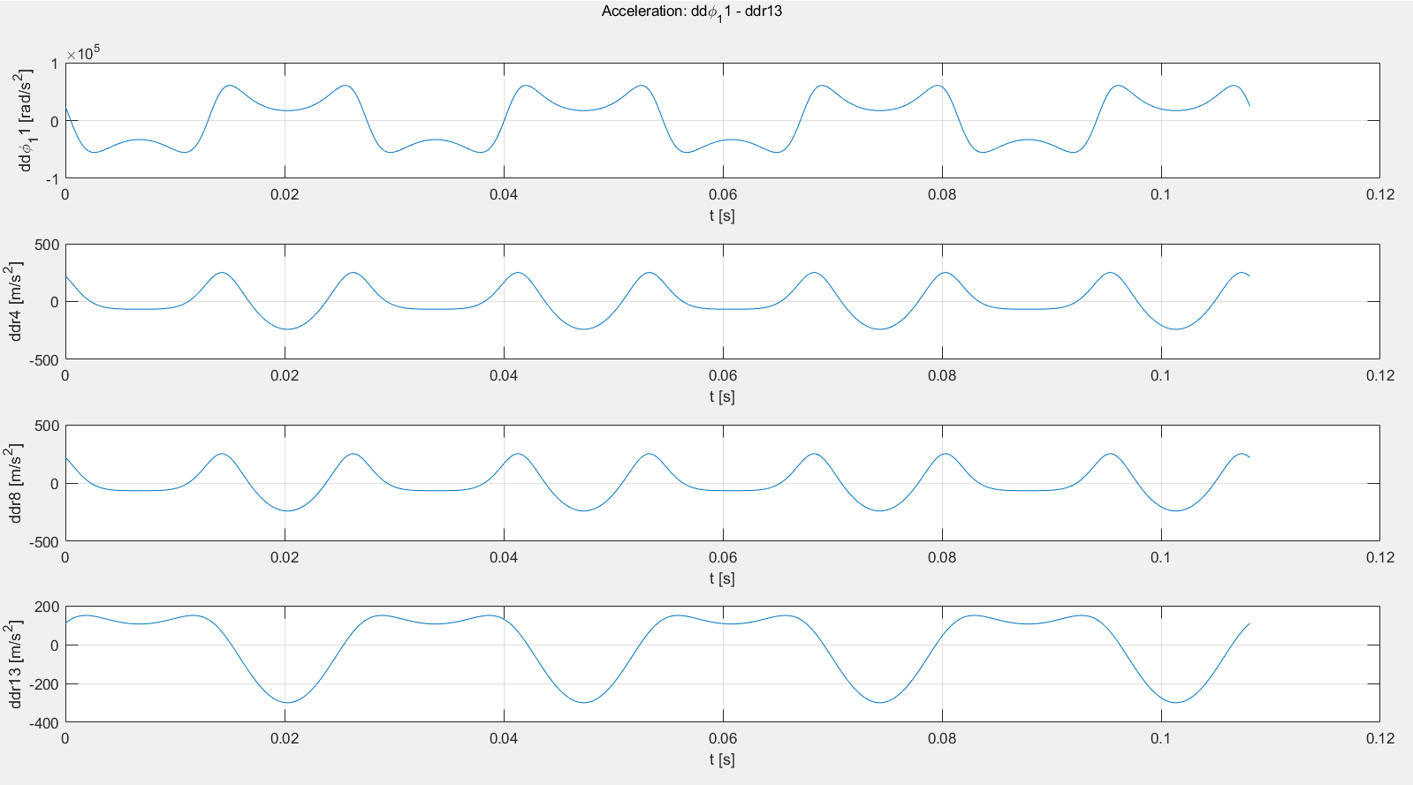

Figure 11: Alpha 11 and the acceleration of the change of length of bars 4, 8 and distance 13

## Control

All angles, velocities and accelerations have been analytically calculated, using the loop equations, in the sections above. These results must be checked by using other methods to calculate the positions, velocities and accelerations. First the position will be checked by a simple animation made in matlab to see if the system moves correctly, after this the position of a point will be calculated starting from two different points. Next the velocity and the acceleration will be checked using the numerical derivatives and by using two different points. Three points will be tested each time, point C and a point in each wing to make sure every subpart moves correctly.

### Position

The animation made in matlab makes the correct movements and figure 12 shows the correct starting position. Which means this first check of the position is correct. The wings have been left out of the animation and figure 12 because they don’t influence the kinematic analysis.

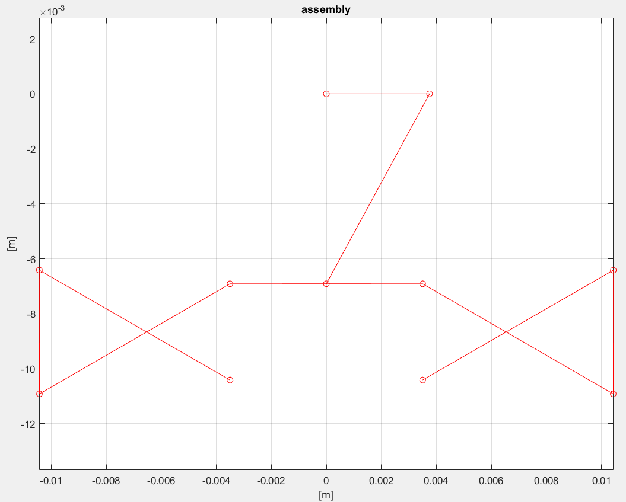

Figure 12: The desired starting position of the system

Next, three positions are calculated using two different starting points. Only three positions are checked because we already saw that the system is moving correctly, and the position of the other points depend on each other. A point in each moving part is chosen. The position of F is calculated using D-E-F and using G-F. The position of I is calculated using K-J-I and using H-I. The position of C is calculated using A-B-C and using D-C. The absolute and relative errors can be found in figure 13.

The absolute error and relative error are not as small as espected. Matlab stores and operates in doubles, which means it gives about 15 or 16 correct decimal digits. The bigger error can be explained by the high frequency of 37Hz at which the system moves. For the most part the error is about 0 on the scale used in figure 13.

As an example figure 14 show the same position control of the same joints at a lower frequency. Here the expected accuracy is achieved.

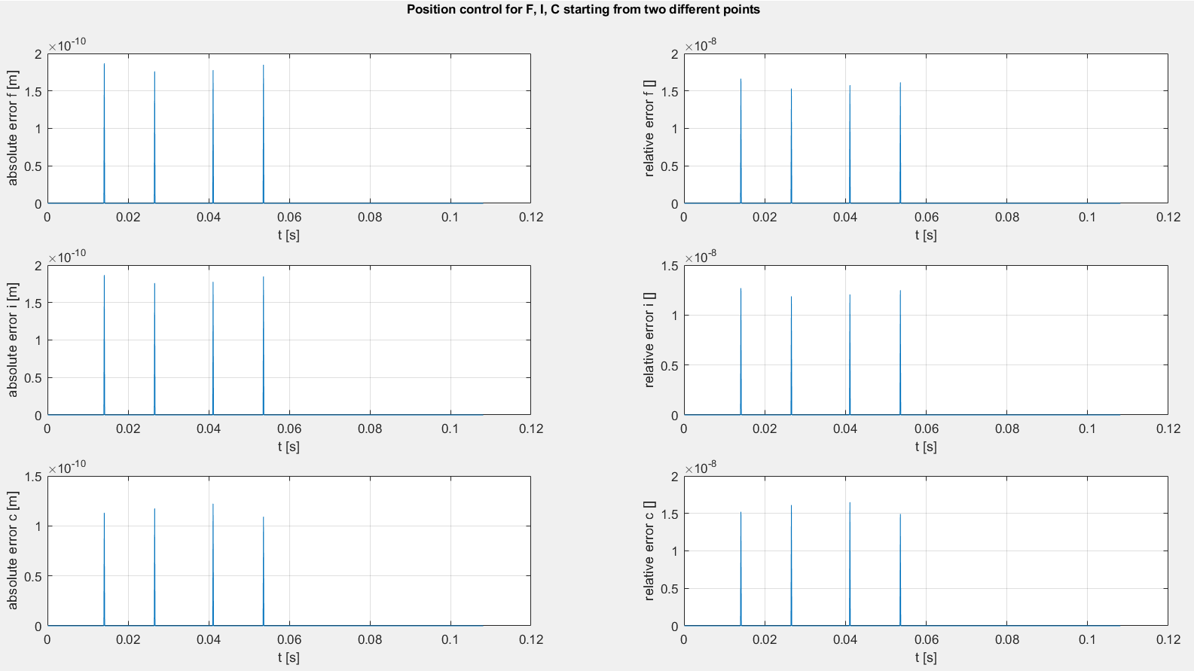

Figure 13: Position control of joints F, I and C.

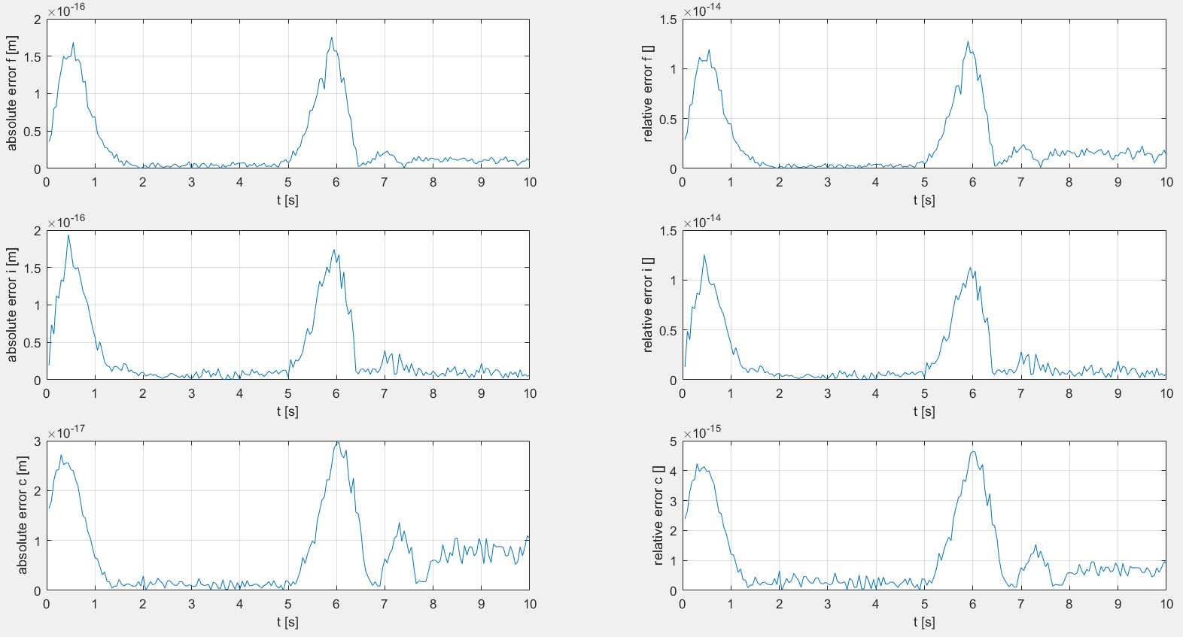

Figure 14: Position control of joints F, I and C at a lower frequency

### Velocity

To check the velocity two different tests are used, first the velocities of three points are checked using numerical differentiation, second, like the position check, the velocities of two points are calculated starting from two different points.

Figure 15 shows the numerical differentiation errors of angles 3, 6 and 10. The errors are nowhere near the machines accuracy discussed in the section above. This bad accuracy can be explained by the high frequency and small Ts = 0.0001 through which we are dividing. Because Ts is so small any mistake will become a lot bigger.

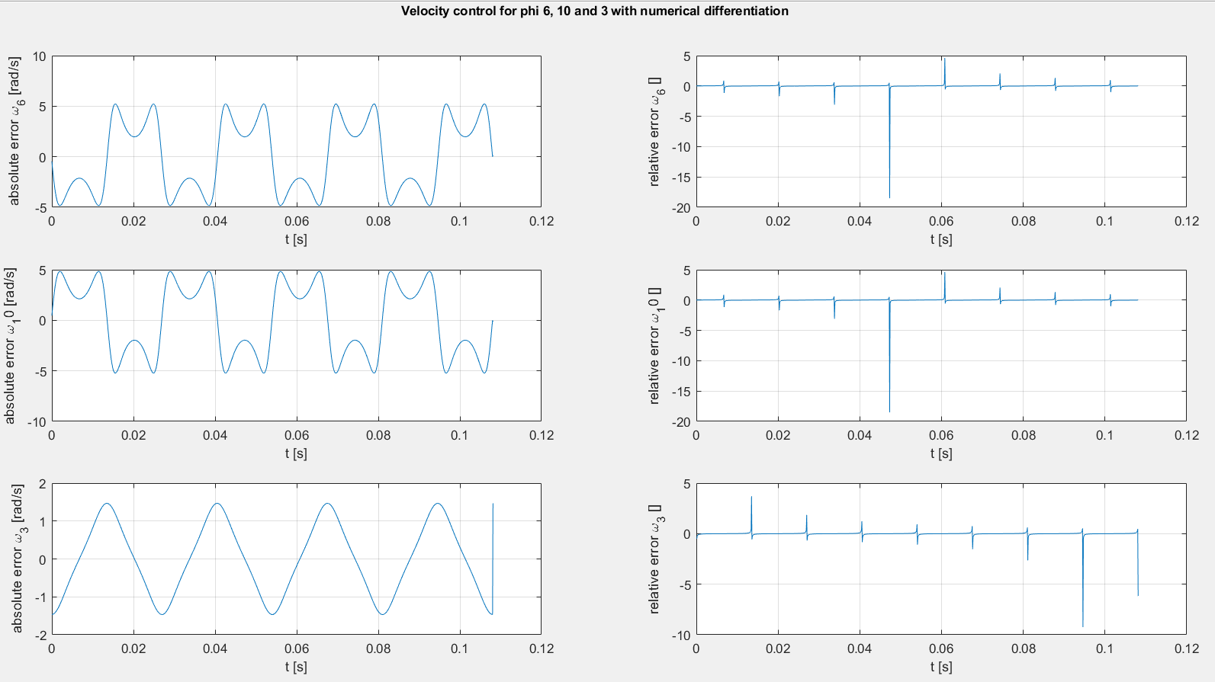

Figure 15: Velocity control of omega 3, 6 and 10 with numerical differentiation

Figure 16 shows the velocity control of joint F using G-F and D-E-F and joint J using K-J and H-I-J. The error has the expected machine accuracy of matlab. Because of the accuracy of the second test and the shape of the velocity figures the calculated velocities are correct.

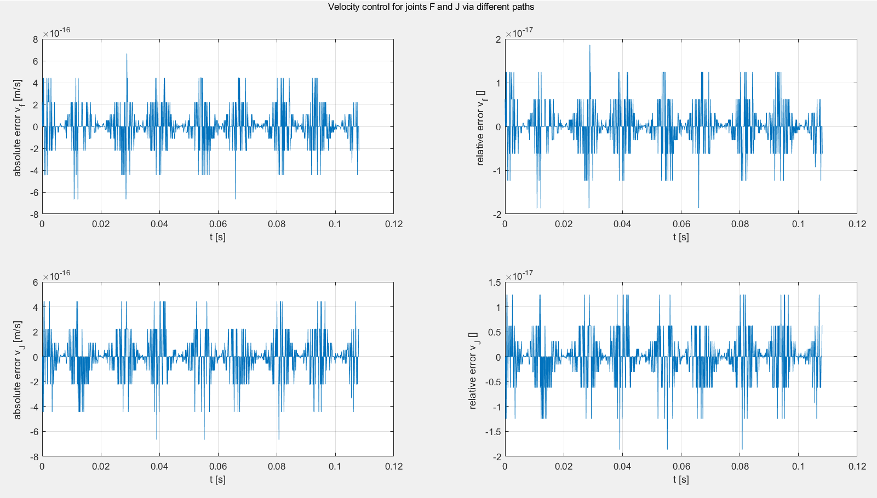

Figure 16: Velocity control for joints F and J via different paths

### Acceleration

The acceleration analysis is checked in a similar way as the velocity analysis. First numerical differentiation is used, and then different paths are used.

Figure 17 shows the numerical differentiation check for angles 3, 6 and 10. A big error is found, this can again be explained by the high frequency and thus low Ts at which the system works and is calculated.

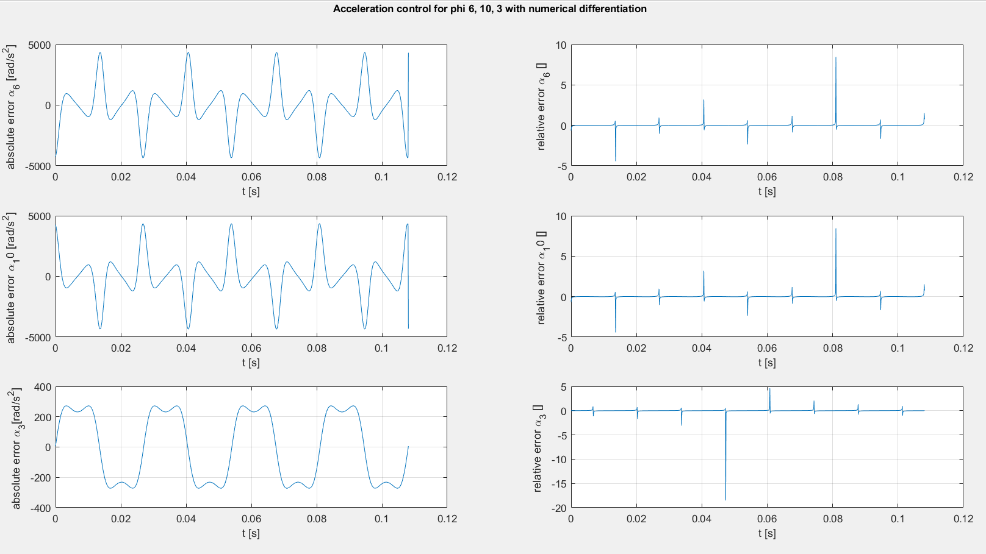

Figure 17: Acceleration control for angles 3, 6 and 10 using numerical differentiation

Figure 18 shows the acceleration check for joints F and J. The error has the expected machine accuracy of matlab. Because of the accuracy of the second test and the shape of the acceleration figures the calculated accelerations are correct.

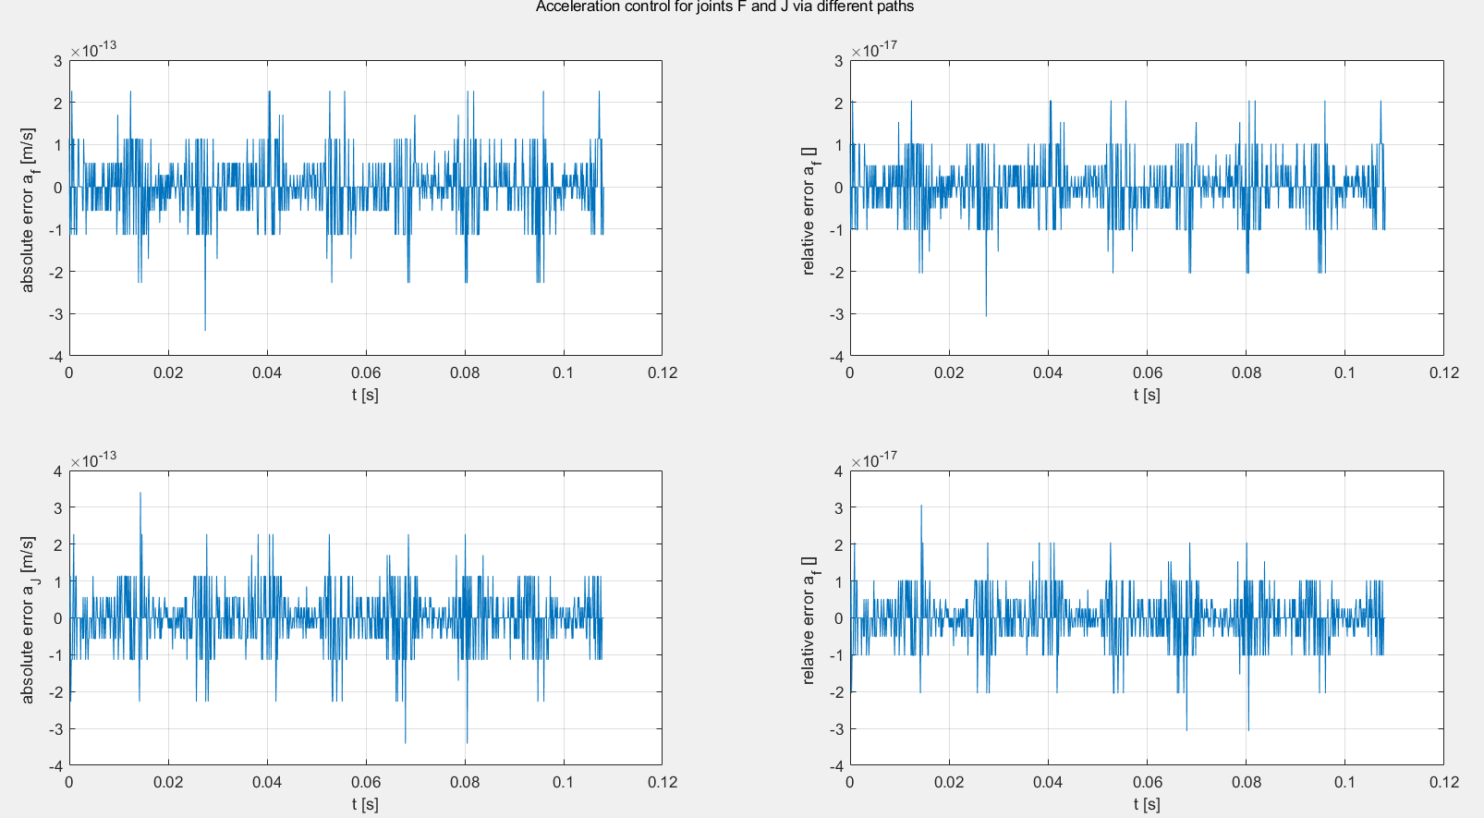

Figure 18: Acceleration control of joints F and J using different paths

# Dynamic analysis

Once the kinematic model has been completed and tested, the mechanism is analysed analytically in order to design the motor and the linkages.

## Centre of gravity

As the most important force in the linkage is the inertial force, a good estimation of each centre of gravity (cog) is essential. The nomenclature is as such: $cog{x_{A}}_{i}$ is the coordinate over the i-axis of the centre of gravity of link x seen from the relative frame of point A.

Link 4-5 and 8-9 are linked and can thus be seen as one bar. Their mass density and cross area are assumed to be identical. As the link lengths $r_{4}$ and $r_{8}$ varied in the kinematic analysis, the maximal length is taken as the true length of the link, necessary for the position of the total centre of gravity.

Eg. if the cog of bar 1 is on 5 meters along the positive x-axis with respect of A, $cog{1_{A}}_{x}=5$.

At first the position of the centre of gravity in the frame of reference of each link is calculated.

|  |  |  |
| --- | --- | --- |
| Centre of gravity in the relative frame of reference | X | Y |
| 2 | $$\frac{r_{2}}{2}$$ | $$0$$ |
| 3 | $$\frac{r_{3}}{2}$$ | $$0$$ |
| 4 | $$\frac{r_{max4}}{2}$$ | $$0$$ |
| 5 | $$\frac{r_{5}}{2}$$ | $$0$$ |
| 6 | $$\frac{r_{6}}{2}$$ | $$-\frac{r_{wing}^{2}}{2*\left(r_{wing}+r_{6}\right)}$$ |
| 7 | $$\frac{r_{7}}{2}$$ | $$0$$ |
| 8 | $$\frac{r_{max8}}{2}$$ | $$0$$ |
| 9 | $$\frac{r_{9}}{2}$$ | $$0$$ |
| 10 | $$\frac{r_{10}}{2}$$ | $$\frac{r_{wing}^{2}}{2*\left(r_{wing}+r_{10}\right)}$$ |
| 11 | $$\frac{r_{11}}{2}$$ | $$0$$ |
| wing |  |  |

|  |  |
| --- | --- |
| Centres of gravity |  |
| $$cog2_{A_{x}}$$ | $$X_{2}*cos⁡(φ_{2})$$ |
| $$cog2_{A_{y}}$$ | $$X_{2}*sin⁡(φ_{2})$$ |
| $$cog{2_{B}}_{x}$$ | $$-X_{2}*cos⁡(φ_{2})$$ |
| $$cog{2_{B}}_{y}$$ | $${-X}_{2}*sin⁡(φ_{2})$$ |
| $$cog{3_{B}}_{x}$$ | $${-X}_{3}*cos⁡(φ_{3})$$ |
| $$cog3_{B_{y}}$$ | $$-X_{3}*sin⁡(φ_{3})$$ |
| $$cog{3_{C}}_{x}$$ | $$X_{3}*cos⁡(φ_{3})$$ |
| $$cog{3_{C}}_{y}$$ | $$X_{3}*sin⁡(φ_{3})$$ |
| $$cog{45}_{D_{x}}$$ | $$\frac{{-r_{max4}*X}_{4}*\cos\left(φ_{4}\right)+r_{5}*X_{5}*\cos\left(φ_{5}\right)}{r_{max4}+r_{5}}$$ |
| $$cog{45}_{D_{y}}$$ | $$\frac{{-r_{max4}*X}_{4}*\sin\left(φ_{4}\right)+r_{5}*X_{5}*\sin\left(φ_{5}\right)}{r_{max4}+r_{5}}$$ |
| $$cog{6_{E}}_{x}$$ | $$X_{6}*cos\left(φ_{6}\right)- Y_{6}*sin(φ_{6})$$ |
| $$cog6_{E_{y}}$$ | $$X_{6}*sin\left(φ_{6}\right)+ Y_{6}*cos(φ_{6})$$ |
| $$cog{6_{F}}_{x}$$ | $${-X}_{6}*cos\left(φ_{6}\right)- Y_{6}*sin(φ_{6})$$ |
| $$cog6_{F_{y}}$$ | $$-X_{6}*sin\left(φ_{6}\right)+ Y_{6}*cos(φ_{6})$$ |
| $$cog7_{F_{x}}$$ | $$X_{7}*cos⁡(φ_{7})$$ |
| $$cog7_{F_{y}}$$ | $$X_{7}*sin⁡(φ_{7})$$ |
| $$cog7_{G_{x}}$$ | $${-X}_{7}*cos⁡(φ_{7})$$ |
| $$cog7_{G_{y}}$$ | $$-X_{7}*sin⁡(φ_{7})$$ |
| $$cog89_{H_{x}}$$ | $$\frac{{-r_{max8}*X}_{8}*\cos\left(φ_{8}\right)+r_{9}*X_{9}*\cos\left(φ_{9}\right)}{r_{max8}+r_{9}}$$ |
| $$cog89_{H_{y}}$$ | $$\frac{{-r_{max8}*X}_{8}*\cos\left(φ_{8}\right)+r_{9}*X_{9}*\cos\left(φ_{9}\right)}{r_{max8}+r_{9}}$$ |
| $$cog{{10}_{I}}_{x}$$ | $$X_{10}*cos\left(φ_{10}\right)- Y_{10}*sin(φ_{10})$$ |
| $$cog{10}_{I_{y}}$$ | $$X_{10}*sin\left(φ_{10}\right)+ Y_{10}*cos(φ_{10})$$ |
| $$cog{{10}_{J}}_{x}$$ | $${-X}_{10}*cos\left(φ_{10}\right)- Y_{10}*sin(φ_{10})$$ |
| $$cog{10}_{J_{y}}$$ | $$-X_{10}*sin\left(φ_{10}\right)+ Y_{10}*cos(φ_{10})$$ |
| $$cog{{11}_{J}}_{x}$$ | $$X_{11}*cos⁡(φ_{11})$$ |
| $$cog{11}_{J_{y}}$$ | $$X_{11}*sin⁡(φ_{11})$$ |
| $$cog{11}_{K_{x}}$$ | $$-X_{11}*cos⁡(φ_{11})$$ |
| $$cog11_{K_{y}}$$ | $${-X}_{11}*sin⁡(φ_{11})$$ |

## Masses and moments of inertia

In a moving system, the mass and inertial moment can have a big influence on the behaviour of the linkage. As an estimation every link is assumed to have an identical thickness of 2mm. In the report on which this linkage is based, the usage of epoxy glass laminate is recommended. This material has a density $ϱ=1800kg/m^{3}$. Or in other words the links weigh 5.65 g/m. By multiplying it with the length of a link, that link’s mass can be obtained: $m=ϱ*A*l$. Note that the wings are also simplified as links.

Apart from link 4, 5, 8 and 9 each moment of inertia is calculated in its centre of gravity. As later on the moment equation of link 4-5 and 8-9 will be calculated in their fixed points, respectively D and H, their moment of inertia also has to be calculated on that spot using the Steiner’s formula

$J_{iA}=J_{icog}+m_{i}*d_{Acog}^{2}$.

As the moments of inertia are calculated on the same spot, the total moment of inertia of link 4-5 and 8-9 is simply the sum of the inertia of each link. $J_{45cog}$ and $J_{89cog}$ are the moment of inertia in the centre of gravity

|  |  |
| --- | --- |
| Moments of inertia |  |
| $$J_{2}$$ | $$m_{2}*r_{2}^{2}/12$$ |
| $$J_{3}$$ | $$m_{3}*r_{3}^{2}/12$$ |
| $$J_{4}$$ | $$m_{4}*r_{max4}^{2}/12+m_{4}*X_{4}^{2}$$ |
| $$J_{5}$$ | $$m_{5}*r_{5}^{2}/12+m_{5}*X_{5}^{2}$$ |
| $$J_{6}$$ | $$m_{6}*\frac{r_{6}^{2}}{12}+r_{6}*Y_{6}^{2}+m_{wing}*\frac{r_{wing}^{2}}{12}+m_{wing}*{\left(-\frac{r_{wing}}{2}-Y_{6}\right)}^{2}$$ |
| $$J_{7}$$ | $$m_{7}*r_{7}^{2}/12$$ |
| $$J_{8}$$ | $$m_{8}*r_{max8}^{2}/12+m_{8}*X_{8}^{2}$$ |
| $$J_{9}$$ | $$m_{9}*r_{9}^{2}/12+m_{9}*X_{9}^{2}$$ |
| $$J_{10}$$ | $$m_{10}*\frac{r_{10}^{2}}{12}+r_{10}*Y_{10}^{2}+m_{wing}*\frac{r_{wing}^{2}}{12}+m_{wing}*{\left(\frac{r_{wing}}{2}-Y_{10}\right)}^{2}$$ |
| $$J_{11}$$ | $$m_{11}*r_{11}^{2}/12$$ |
| $$J_{45}$$ | $$J_{4}+J_{5}$$ |
| $$J_{89}$$ | $$J_{8}+J_{9}$$ |
| $$J_{45cog}$$ | $$J_{45}+m_{45}*(cog{45}_{D_{x}}^{2}+cog{45}_{D_{y}}^{2})$$ |
| $$J_{89cog}$$ | $$J_{89}+m_{89}*(cog{89}_{H_{x}}^{2}+cog{89}_{H_{y}}^{2})$$ |

## Acceleration and velocities

The last parameters that should be calculated before are the accelerations and velocities of the centres of gravity. These will be used for the controls of our calculations.

Each link can be seen as a bar rotating around the origin in their relative frame of reference. As these frames don’t rotate relative to the absolute frame of reference, the speed and acceleration can always be derived from the following formula for a point A in a frame of reference with as origin O:

$$v_{A}= v_{O}+ω_{A} x r_{OA}$$

$$a_{A}=a_{O}+ω_{A} x ω_{A} x r_{OA}+α_{A} x r_{OA}$$

By meticulously applying these exact equations to each link, starting from its closest fixed point, the accelerations and velocities can be found, as can also be seen in the matlab code. If the link is connected to a fixed point, the absolute motion of the origin is naturally set to zero.

## Force equations

The force on each bar can be calculated with the second law of Newton. This gives three equations for every bar: the force equation in x- and y-direction and the torque equation. As there are 8 individual links, this leads to 24 equations. As you can see on figure 13, this matches exactly the number of unknown forces and moments. Each bar will be discussed separately. 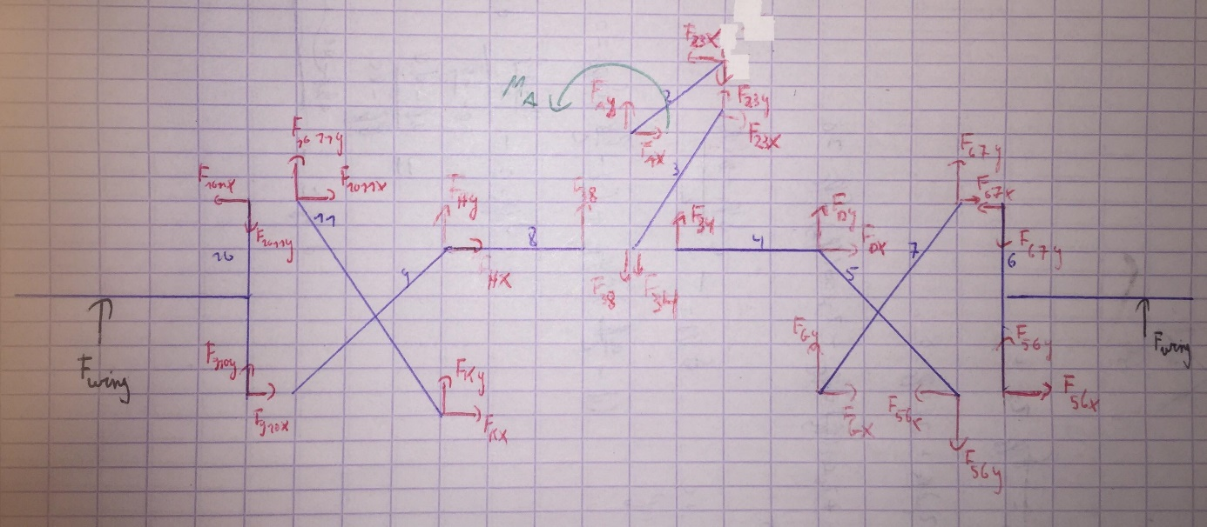

Figure 19: The forces on each bar

Bar 2 has four unknown forces and one unknown moment. The equations are

$$F_{A_{x}}-F_{{23}_{x}}=m_{2}*a_{2_{x}}$$

$$F_{A_{y}}-F_{{23}_{y}}=m_{2}*a_{2_{y}}$$

$$cog2_{A_{y}}*F_{A_{x}}-cog2_{A_{x}}*F_{A_{y}}-cog2_{B_{y}}*F_{{23}_{x}}+cog2_{B_{x}}*F_{{23}_{y}}+M_{A}=J_{2}*α_{2}$$

Bar 3 is a special case: even though the top part is as usual, the bottom part has three different forces: the reaction force of bar 4 and 8 and the external force of C. Note that the slider limits the force in C to be only horizontal.

$$F_{{23}_{x}}+F_{C_{x}}+F_{34}*\sin\left(φ_{4}\right)-F_{38}*\sin\left(φ_{8}\right)=m_{3}*a_{3_{x}}$$

$$F_{{23}_{y}}-F_{34}*\cos\left(φ_{4}\right)+F_{38}*\cos\left(φ_{8}\right)=m_{3}*a_{3_{y}}$$

$cog{3_{B}}_{y}*F_{{23}_{x}}-cog{3_{B}}_{x}*F_{{23}_{y}}+cog3_{C_{y}}*F_{C_{x}}+\left(cog{3_{C}}_{y}*\sin\left(φ_{4}\right)+cog3_{C_{x}}*\cos\left(φ_{4}\right)\right)*F_{34}-\left(cog{3_{C}}_{y}*\sin\left(φ_{8}\right)+cog3_{C_{x}}*\cos\left(φ_{8}\right)\right)*F_{38}=J_{3}*α_{3}$

Bar 45 has 5 reaction forces and a fixed point. In order to facilitate the torque equation, the moment around point D has been taken.

$$-\sin\left(φ_{4}\right)*F_{34}+F_{D_{x}}-F_{{58}_{x}}=m_{45}*a_{{45}_{x}}$$

$$\cos\left(φ_{4}\right)*F_{34}+F_{D_{y}}-F_{{58}_{y}}=m_{45}*a_{{45}_{y}}$$

$$-r_{4}*F_{34}-{d_{ED}}_{y}*F_{{56}_{x}}+d_{ED_{x}}*F_{{56}_{y}}=J_{45}*α_{4}$$

Bar 6 has apart from his 4 usual reaction forces also a known external force $F_{wing}=0.12N$. This adds an extra term in the equations.

$$F_{{56}_{x}}-{F_{67}}_{x}=m_{6wing}*{a_{6}}_{x}-F_{wing}*cos⁡(φ_{6})$$

$$F_{{56}_{y}}-{F_{67}}_{y}=m_{6wing}*{a_{6}}_{y}-F_{wing}*sin⁡(φ_{6})$$

$$cog6_{E_{y}}*F_{{56}_{x}}-cog6_{E_{x}}*F_{{56}_{y}}-cog6_{F_{y}}*F_{{67}_{x}}+cog6_{F_{x}}*F_{{67}_{y}}=J_{6}*α_{6}-\left(Y_{6}+Y_{wing}\right)*F_{wing}$$

Bar 7 is a normal bar with 4 reaction forces and a fixed point in G

$$F_{{67}_{x}}+F_{G_{x}}=m_{7}*{a_{7}}_{x}$$

$$F_{{67}_{y}}+F_{G_{y}}=m_{7}*a_{7_{y}}$$

$$cog7_{F_{y}}*F_{{67}_{x}}-cog7_{F_{x}}*F_{67y}+cog7_{G_{y}}*F_{G_{x}}-cog7_{G_{x}}*F_{G_{y}}=J_{7}*α_{7}$$

Bar 89, 10 and 11 are mirrors of 45, 6 and 7 respectively:

Bar89 has a fixed point on H:

$$\sin\left(φ_{8}\right)*F_{38}+F_{H_{x}}-F_{{910}_{x}}=m_{89}*a_{{89}_{x}}$$

$$-cos\left(φ_{8}\right)*F_{38}+F_{H_{y}}-F_{{910}_{y}}=m_{89}*a_{{89}_{y}}$$

$$r_{8}*F_{38}-{d_{IH}}_{y}*F_{{910}_{x}}+d_{IH_{x}}*F_{{910}_{y}}=J_{89}*α_{8}$$

Bar10 also has a force $F_{wing}$ pushing on its wing:

$$F_{{910}_{x}}-{F_{1011}}_{x}=m_{10wing}*{a_{10}}_{x}-F_{wing}*cos⁡(φ_{10})$$

$$F_{{910}_{y}}-{F_{1011}}_{y}=m_{10wing}*{a_{10}}_{y}-F_{wing}*sin⁡(φ_{10})$$

$$cog{10}_{I_{y}}*F_{{910}_{x}}-cog{10}_{I_{x}}*F_{{910}_{y}}-cog{10}_{J_{y}}*F_{{1011}_{x}}+cog{10}_{J_{x}}*F_{{1011}_{y}}=J_{10}*α_{10}-\left(Y_{10}-Y_{wing}\right)*F_{wing}$$

Bar11 is fixed to point K:

$$F_{{1011}_{x}}+F_{K_{x}}=m_{11}*{a_{11}}_{x}$$

$$F_{{1011}_{y}}+F_{K_{y}}=m_{11}*a_{{11}_{y}}$$

$$cog{11}_{J_{y}}*F_{{1011}_{x}}-cog{11}_{J_{x}}*F_{1011y}+cog{11}_{K_{y}}*F_{K_{x}}-cog{11}_{K_{x}}*F_{K_{y}}=J_{11}*α_{11}$$

In order to solve these equations with a matrix method, the 24 equations are arranged in an Ax=b format. x contains the 24 unknowns. This gives this arrangement, the A-matrix is written down in figure 14:

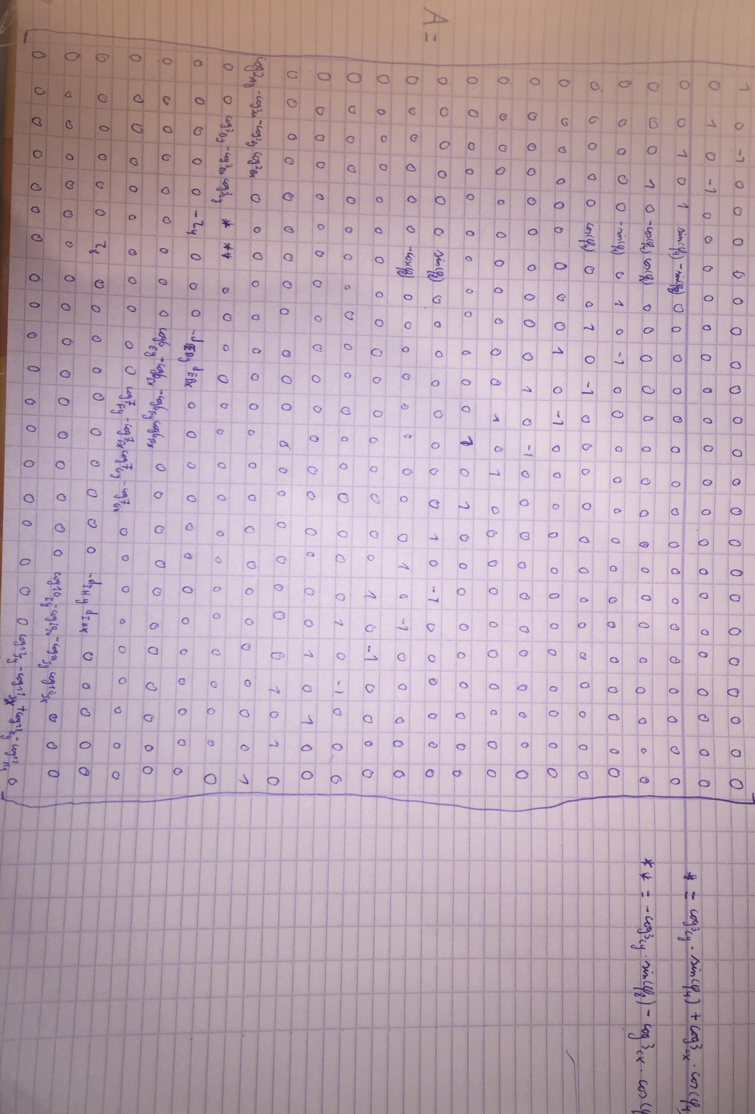

Figure 20: the A-matrix

$$B=\left[\begin{matrix}m_{2}*a_{2x} \\ m_{2}*a_{2y} \\ \begin{matrix}m_{2}*a_{3x} \\ m_{3}*a_{3y} \\ \begin{matrix}m_{45}*a_{45x} \\ m_{45}*a_45y \\ \begin{matrix}m_{6wing}*a_{6x}-F_{wing}*cos⁡(φ_{6}) \\ m_{6wing}*a_{6x}-F_{wing}*sin⁡(φ_{6}) \\ \begin{matrix}m_{7}*a_{7x} \\ m_{7}*a_{7y} \\ \begin{matrix}m_{89}*a_{89x} \\ m_{89}*a_{89y} \\ \begin{matrix}m_{10wing}*a_{10x}-F_{wing}*cos⁡(φ_{10}) \\ m_{10wing}*a_{10y}-F_{wing}*sin⁡(φ_{10}) \\ \begin{matrix}m_{11}*a_{11x} \\ m_{11}*a_{11y} \\ \begin{matrix}J_{2}*α_{2} \\ J_{3}*α_{3} \\ \begin{matrix}J_{45}*α_{4} \\ J_{6}*α_{6}-\left(Y_{6}+Y_{wing}\right)*F_{wing} \\ \begin{matrix}J_{7}*α_{7} \\ J_{89}*α_{89} \\ \begin{matrix}J_{10}*α_{10}-\left(Y_{10}-Y_{wing}\right)*F_{wing} \\ J_{11}*α_{11}\end{matrix}\end{matrix}\end{matrix}\end{matrix}\end{matrix}\end{matrix}\end{matrix}\end{matrix}\end{matrix}\end{matrix}\end{matrix}\end{matrix}\right] , X= \left[\begin{matrix}F_{A_{x}} \\ F_{A_{y}} \\ \begin{matrix}F_{{23}_{x}} \\ F_{{23}_{y}} \\ \begin{matrix}{F_{C}}_{x} \\ F_{34} \\ \begin{matrix}F_{38} \\ F_{D_{x}} \\ \begin{matrix}{F_{D}}_{y} \\ F_{{56}_{x}} \\ \begin{matrix}F_{{56}_{y}} \\ F_{{67}_{x}} \\ \begin{matrix}F_{{67}_{y}} \\ F_{G_{x}} \\ \begin{matrix}F_{G_{y}} \\ F_{H_{x}} \\ \begin{matrix}F_{H_{y}} \\ F_{{910}_{x}} \\ \begin{matrix}F_{{910}_{y}} \\ F_{{1011}_{x}} \\ \begin{matrix}F_{{1011}_{y}} \\ F_{K_{x}} \\ \begin{matrix}F_{K_{y}} \\ M_{A}\end{matrix}\end{matrix}\end{matrix}\end{matrix}\end{matrix}\end{matrix}\end{matrix}\end{matrix}\end{matrix}\end{matrix}\end{matrix}\end{matrix}\right]$$

## Results

### Internal forces

At first the internal forces will be discussed by plotting the x and y component of each force.

The forces on bar 2 and 3, plotted on figure 15, are limited below 50N in absolute value. As expected, there is symmetry between $F_{23}$ and $F_{A}$ and between $F_{34}$ and $F_{38}$. The forces on point three are also strictly positive in the x-direction.



Figure 21: Forces on bar 2 and 3

There is a clear symmetry between the forces on the left and right wing, respectively figure 16 and 17. Even though the forces on the fixed points D and H go up to 35N in absolute value, the reaction forces on the nodes all stay well below 15 N.



Figure 22: Forces on the right wing

Figure 23: Forces on the left wing

### Torque on the motor

The torque on the motor is visible on figure 18. In the report on which the mechanism is based, the MK07-08 motor from DiDEL is proposed. This motor can generate a nominal torque of 0.37Nmm at 40 000rpm. By using a 20:1 gearbox, this can be scaled to 7.4Nmm. This is clearly too weak for this mechanism, as the mean torque is 61.5 Nmm. However, in the report, some excessive balancing has been done.



Figure 24: the torque on the motor

### Force and torque after static balancing

As a first effort to balance the mechanism, ideal counterweights are added on bar 2, 45 and 89, in order to get the cog in respectively the fixed points A, D and H. The counterweights are considered ideal as they did not influence the moment of inertia. This is only an approximation of the reality and merely gives mere an upper limit of the balancing. The results are shown in figure 19. Static balancing had barely any influence on the reaction forces, but we did succeed to halve the mean torque to 30.8 Nmm. Even better results can be obtained by dynamic balancing the system after a forward force analysis.



Figure 25: torque and force after balancing

### Shaking forces

The total shaking force is the sum of the forces on each fixed point. These forces will be transmitted on the mechanism and must be as constant as possible in order to have a continuous flight and are important for resonance. The result can be seen in figure 20. The shaking forces in the x-direction are very low and vibrate on 37 Hz, the driving frequency. However, the shaking force in the y-direction are a lot higher and have a second important harmonic at 74 Hz, twice the driving frequency.



Figure 26: Shaking forces

## Control

Off course it is also important to check the validity of the model by calculating the results in different ways. Both the energy method, the method of virtual are used to check the validity of the model.

The torque has been recalculated by the energy method:

$$\dot{E}=M_{A}*\dot{φ_{2}+F_{wing}*v_{6wing}+F_{wing}*v_{10wing}}=\sum_{i=2}^{11}{m_{i}*\left(v_{ix}*a_{ix}+v_{iy}*a_{iy}\right)+J_{cogi}*ω_{i}*α_{i}}$$

From this equation $M_{A}$ can be easily calculated. However, as can be seen on figure 21, it does not exactly equal the $M_{A}$ that was previously calculated. That suggests that a term has been forgotten in the energy or matrix equation. However, the error is relatively small, so all previous observations stay legitimate. In order to find the error, all equations have been checked and rechecked. By setting all masses and $F_{wing}$ on 0 and slowly adding bar after bar, the error came forward as soon as bar 45 and 89 were added. That means there must be a mistake in the equations concerning these bars.



Figure 27: control of the torque on the motor

The control of the shaking forces is done by virtual work. This is done by moving the entire mechanism with a virtual movement $δx$ for the x-components and with $δy$ for the y-components consecutively. This gives these equations:

$$F_{A_{x}}+F_{C_{x}}+F_{D_{x}}+F_{G_{x}}+F_{H_{x}}+F_{K_{x}}+F_{wing}*\left(\cos\left(ϕ_{6}\right)+\cos\left(ϕ_{10}\right)\right)=\sum_{i=2}^{11}{m_{i}*a_{ix}}$$

$$F_{A_{y}}+F_{D_{y}}+F_{G_{y}}+F_{H_{y}}+F_{K_{y}}+F_{wing}*\left(\sin\left(ϕ_{6}\right)+sin⁡(φ_{10})\right)=\sum_{i=2}^{11}{m_{i}*a_{iy}}$$

The difference between this control and the shaking forces calculated with the matrix method is plotted in figure 22. The difference between both methods appears as white noise and has the same magnitude as the machine accuracy ($\sim {10}^{-15})$. We can thus conclude that there is no apparent error in the shaking forces.



Figure 28: Difference between the shaking forces of the matrix and virtual work method

## Strength analysis

At last it is interesting to calculate the maximal forces on the system and compare them with the results. As the 2mm diameter of each bar is estimated, this also gives a feedback if the estimation is realistic.

The yield strength of epoxy glass is 870 MPa. There can be both torques and stretching forces on a bar.

The maximal stretching force on a bar is: $F=σ*A= σ*π*\frac{d^{2}}{4}=2733N$

The maximal torque on a bar is: $M=\frac{2*σ*I}{d}=\frac{σ*d^{4}*π}{d*32}=0.68Nm$

# Conclusion

The 9-bar linkage system was thoroughly analysed. First a motion analysis was done to determine the degree of freedom of the system. After which a kinematic and an inverse dynamic analysis was done.

The kinematic analysis gave good results according to the error checks, which was important as the dynamic analysis used these results. The numerical differentiation checks gave a low accuracy, but the correctness of the system was confirmed through the different paths approach and by comparing the figures.